IHW 2007 Important Workshop Information

We are looking forward to seeing you in Asheville, North Carolina on Saturday July 7th to kick off the 32nd Annual International Herpesvirus Workshop. The following information will help you prepare for your trip and know what to expect while at the Workshop.

WEATHER: Asheville, North Carolina has mild summer weather. July is the warmest month of the year with average temperatures around 74°, with a low of 64° and a high of 84°. The average rainfall in July is 3.87 inches.

TRAVEL/TRANSPORTATION: The Asheville Regional Airport is located approximately 20 minutes from downtown Asheville and the IHW host hotels. Shuttles and Taxi’s are not permitted to wait onsite at the airport to pick up passengers on demand. Advance reservations for transportation are recommended. Ground transportation is located on the baggage claim level of the Asheville Airport.
AIRPORT SHUTTLE SERVICES

Metro Cab Van and Taxi Service
Advance reservations recommended
Phone: 828.254.1155
Email: eta.metrocab@yahoo.com
Fax: 828.350.0823

Metro Cab Van and Taxi Service are offering IHW a discounted $40 flat rate fare each way per vehicle from the Asheville Airport to the three conference hotels. Approximately 4-5 people can be accommodated in a van and 2-3 people in a car. The $40 flat rate fare per vehicle will be divided equally between the passengers.

Please email or fax Metro Cab with your arrival and departure dates/times and hotel you will be staying at prior to arrival. Mention you are with IHW to receive the $40 flat rate fare.

Upon Arrival go to baggage claim level to ground transportation for pick up. Visa, MasterCard and American Express accepted.

Airport Limousine
Advance reservations required
Phone: 828.670.7488
Email: ashevillebraves@hotmail.com
Fax: 828.670.8228

Airport Limousine is offering IHW the following per person one way fares from the Asheville Airport (AVL) to any of the three conference hotels: $45 for 1 passenger; $40 each for 2-3 passengers, $35 each for 4-6 passengers and $30 each for 7+ passengers.

Please email, fax or call Airport Limousine with your: arrival and departure dates/times AM/PM, name of airline and flight numbers and name of conference hotel you will be staying. Mention you are with IHW.

Upon arrival at the Asheville Regional Airport (AVL) continue through the main lobby area, turn right toward the baggage claim level. At the baggage claim area, look for the Airport Limousine/IHW signs, tell the greeter your name/group, they will mark your name on the IHW group list and guide you to your driver.

TAXI
Taxis are not available on demand at the airport. One way fare is approximately $45 from the airport to the conference hotels.

- Yellow / Beaver Lake Cab
Advance reservations recommended
Phone: 828.253.3311

- Your Cab II
Advance reservations recommended
Phone: 828.259.9904
For additional Asheville Airport transportation information visit: www.flyavl.com
BY AUTOMOBILE

Driving Directions:
Take I-26 West to I-240 East, which will bring you to Asheville. Please visit individual hotel websites for specific directions to each Conference Hotel.

HOTEL & VENUE CONTACT INFORMATION:

Haywood Park Best Western Renaissance Asheville
www.haywoodpark.com www.bestwestern.com www.marriott.com
One Battery Park Ave 22 Woodfin Street One Thomas Wolfe Plaza
Asheville, NC 28801 Asheville, NC 28801 Asheville, NC 28801
1-828-252-2522 1-828-253-1851 1-828-252-8211

Civic Center
87 Haywood St
Asheville, NC 28801
1-828-259-5736

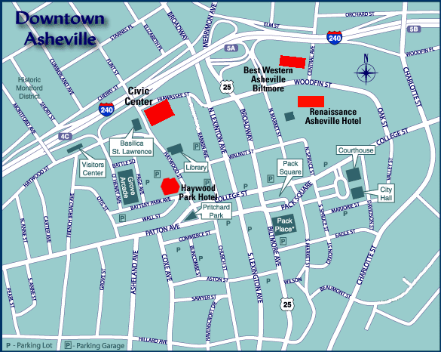

Saturday and Sunday Agenda

Saturday, July 7th
7:30 am -8:30 pm Registration Renaissance Hotel

8:00 am -12:00 pm Satellite Session: HSV Salon C

8:00 am -12:00 pm Satellite Session: Windsor Ballroom
Betaherpesvirus

12:00 pm -5:00 pm Satellite Session: Veterinary Swannanoa Room
Saturday, July 7th Continued

1:00 pm -5:00 pm Satellite Session: VZV Windsor Ballroom

1:00 pm -5:00 pm Satellite Session: Interventions Salon C

6:30 pm -8:30 pm Welcome Reception Grand Ballroom

Sunday, July 8th
7:00 am -6:00 pm Registration The Civic Center

7:00 am -8:15 am Breakfast Buffet Civic Center Arena

8:00 am – 9:00 am Opening Remarks/ Civic Center Auditorium
The Subak-Sharpe Lecture

9:00 am -10:30 am Session 1: Gene Expression I Civic Center Auditorium

10:30 am -11:00 am Break Civic Center Concourse

11:00 am -12:30 pm Session 2: Civic Center Auditorium
Glycoproteins and Entry I

12:30 pm -2:00 pm Lunch Civic Center Auditorium

2:00 pm –3:45 pm Session 3: Pathogenesis I Civic Center Auditorium

3:45 pm -4:15 pm Break Civic Center Concourse

4:15 pm – 5:45 pm Session 4: Latency I Civic Center Auditorium

6:00 pm -8:00 pm Dinner Civic Center Arena

8:00 pm -10:00 pm Poster Session I Civic Center Concourse

POSTER SETUP AND DISMANTLE TIMES

Posters will be displayed in the Asheville Civic Center located at 87 Haywood Street.

Poster Setup
Saturday, July 7………………………………..3:00 pm- 6:30 pm (15:00- 18:30)
Sunday, July 8………………………………….8:00 am- 6:00 pm (08:00- 18:00)

Poster Dismantle
Thursday, July 12………………………………5:00 pm – 5:30 pm (17:00- 17:30)

NOTE: ALL POSTERS MUST BE REMOVED THURSDAY BY 5:30 PM.

SYMPOSIUM AND WORKSHOP PRESENTER INFORMATION:

Please refer to the following schedule and bring your presentation to the Presenter Check-in Desk during the designated times. Please note that presentations not submitted in time may result in your talk not being accompanied by graphics. Presentations may be brought in on CD or USB Sticks. The Workshop will have USB sticks available at the presenter check-in desk.

All speakers must use computers provided by the workshop for their oral
presentations. All computers provided by the conference will be equipped with WinXP or Mac OS 10.3. PowerPoint is the only acceptable format. Personal laptops may not be used. To accommodate this, the organizers have set up the following schedule to ensure that all sessions flow smoothly.

Presentation Date Presentation Time Presentation Turned In By Location
Sunday, July 8 Morning Presentations Saturday 3:00 pm – 6:00 pm Renaissance
Sunday, July 8 Afternoon Presentations Sunday 7:00 am – 12:30 pm Civic Center
Monday, July 9 All Presentations Sunday 7:30 am – 12:30 pm Civic Center
Tuesday, July 10 All Presentations Monday 7:30 am – 12:30 pm Civic Center
Wednesday, July 11 All Presentations Tuesday 7:30 am – 11:00 am Civic Center
Thursday, July 12 All Presentations Wednesday 7:30 am – 12:30 pm Civic Center

A PC and a MAC will be available for presenter use throughout the conference beginning Sunday at the Presenter Check-in desk.

Presenters need to check in with the audio visual meeting coordinator 5 minutes prior to their presentation to receive their wireless lavaliere microphone. The meeting coordinator will be located in the front of the meeting room.

EXCURSIONS: All excursions will depart from the Renaissance Plaza Hotel main lobby and will load in front of the hotel.

Please feel free to contact the staff at Conference Solutions with questions:
1-503-244-4294 ext. 207
Vanessa@conferencesolutionsinc.com

We look forward to seeing all of you at the International Herpesvirus Workshop. www.herpesvirusworkshop.com

